**Experiment Number - 6**

**Student Name:** ANIKET KUMAR **UID:** 20BCS5306

**Branch:** CSE **Section/Group:** 20BCS_WM-703 / B

**Semester:** 5th **Date of Performance:** 11th Oct, 2022

**Subject Name:** PBLJ LAB **Subject Code:** 20CSP-321

1. **Aim/Overview of the practical:**

Playing cards during travel is a fun filled experience. For this game they wanted to collect all four unique symbols. Can you help these guys to collect unique symbols from a set of cards? Create Card class with attributes symbol and number. From our main method collect each card details (symbol and number) from the user. Collect all these cards in a set, since set is used to store unique values or objects. Once we collect all four different symbols display the first occurrence of card details in alphabetical order.

**2. Hardware and Software Requirements :**

PC with windows installed,IntelliJ IDEA (IDE).

**3. Program Code:**

import java.util.HashSet;

import java.util.Scanner;

import java.util.Set;

import java.util.TreeSet;

class Card implements Comparable<Card> {

private char symbol;

private int number;

public Card() {}

public Card(char symbol, int number) {

super();

this.symbol = symbol;

this.number = number;

}

public char getSymbol() {

return symbol;

}

public void setSymbol(char symbol) {

this.symbol = symbol;

}

public int getNumber() {

return number;

}

public void setNumber(int number) {

this.number = number;

}

@Override

public String toString() {

return "Card [symbol=" + symbol + ", number=" + number + "]";

}

@Override

public int compareTo(Card o) {

if (this.symbol < o.symbol) return -1;

else if (this.symbol > o.symbol) return 1;

else return 1;

}

@Override

public int hashCode() {

return String.valueOf(symbol).hashCode();

}

@Override

public boolean equals(Object obj){

if (obj instanceof Card) {

Card card = (Card) obj;

return (card.symbol == this.symbol);

} else {

return false;

}

}

}

public class TestMain {

public static void main(String[] args) {

Scanner sc = new Scanner(System.in);

Set<Card> set = new HashSet<>();

for (int i = 0; i < 8; i++) {

System.out.println("Enter a card:");

Card card = new Card();

card.setSymbol(sc.nextLine().charAt(0));

card.setNumber(sc.nextInt());

sc.nextLine();

set.add(card);

}

System.out.println("Four symbols gathered in eight cards.");

System.out.println("Cards in Set are:");

for (Card card : set)

System.out.println(card.getSymbol() + " " + card.getNumber());

sc.close();

}

}

**4. Output :**

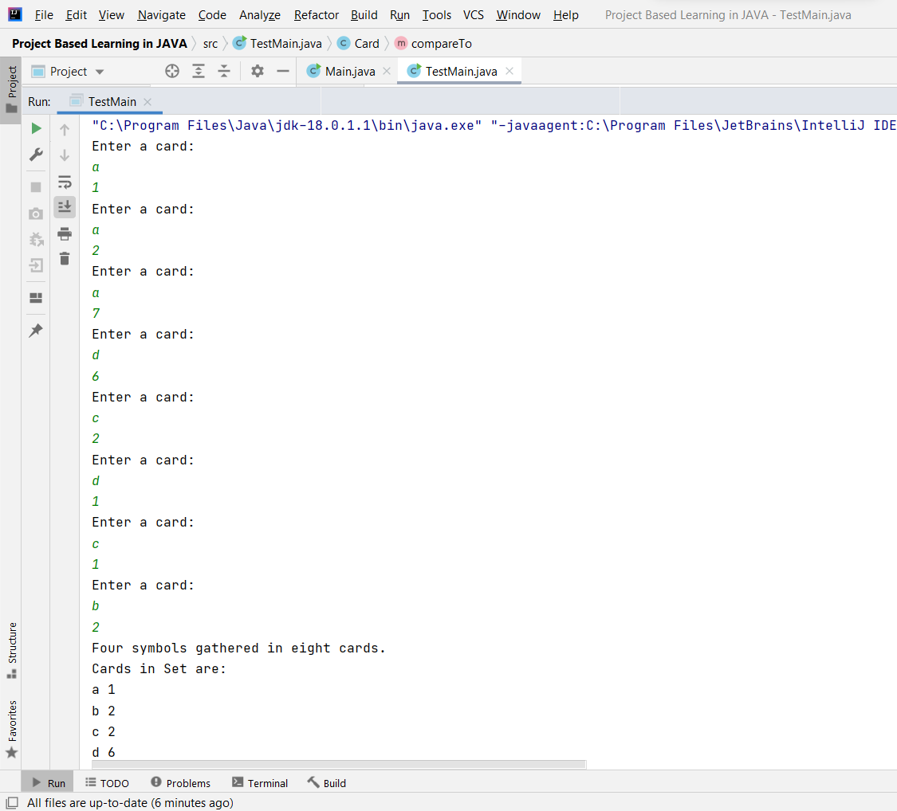

**Learning outcomes (What I have learnt):**

1. I have learnt how to write program in JAVA.
2. I have learnt how to create classes and its objects in JAVA.
3. I have learnt how to take input from user using Scanner class.
4. I have learnt how to create Array in JAVA and traverse each elements using loop.
5. I have learnt how to create an application to Collect all playing cards in a set, since set is used to store unique values or objects. Once we collect all four different symbols display the first occurrence of card details in alphabetical order.

**Evaluation Grid (To be created as per the SOP and Assessment guidelines by the faculty):**

|  |  |  |  |
| --- | --- | --- | --- |
| Sr. No. | Parameters | Marks Obtained | Maximum Marks |
| 1. |  |  |  |
| 2. |  |  |  |
| 3. |  |  |  |
|  |  |  |  |